Monday
Objective(s): I will be able to understand and make use of the past perfect tense.

This week, we are going to learn about past, present, and future perfect tenses. Today we will start with past perfect tense, watch the video https://youtu.be/-TrE6VdtgLE to see how past perfect can be used.

The past perfect is a verb tense which is used to show that an action took place once or many times before another point in the past. In other words, we use the past perfect tense to show an action that was completed prior to another action that took place in the past.

Past Perfect Forms
The past perfect is formed using had + past participle.

Positive: You had studied English before you moved to New York.
Negative: You had not studied English before you moved to New York.
Question: Had you studied English before you moved to New York?

Positive | Negative | Question
I had worked. | I had not worked. | Had I worked?
You had worked. | You had not worked. | Had you worked?

NOTE:
I had not worked = I hadn't worked
I had worked = I'd worked

More examples:
He had learned Spanish before he went to Spain.
President Lincoln had attended the theater before his assassination in 1865.
They had had lunch when I arrived.
She passed the exam because she had worked very hard.

Exercise on past perfect tense:
Rewrite the sentences in the past perfect tense.
- I saw the movie.
_______________________________
- Martha ate her dinner.
_______________________________
- The computer worked well.
________________________________
- The driver went to the garage.
____________________________________________
- My parents said they were going to the new restaurant. ____________________________________________
- Lauren wanted to go to the Bahamas. ____________________________________________
- The team played very well.
____________________________________________
- The artist painted a beautiful painting. ____________________________________________

Now try on your own:
- Write a sentence using the past tense. ____________________________________________
- Write the same sentence using the past perfect tense.
____________________________________________

Fill in the correct form (past perfect).
1. Mary ___________________ (give) me Tony's address before she left.
2. When the boys arrived at the cinema, the film ___________________ (already, start).
3. Before we reached the station, we saw that we ___________________ (lose) our way.
4. All the tickets ___________________ (be) sold before the concert began.
5. They took a shower after they ___________________ (finish) the game. 6. I asked Mr. Green how many books he ___________________ (read)
7. Mum asked me why I ___________________ (not tidy) up my room.
8. Bob was sorry that he ___________________ (told) me the story.
9. Alan watched TV after he ___________________ (have) lunch.
10. The sun ___________________ (shine) yesterday after it ___________________ (be) cold for many weeks.
11. Uncle David ___________________ (go) to the doctor after he ___________________ (be) ill for a month.
12. Before the police ___________________ (catch) the thief, he ___________________ (steal) two more watches.
13. Mum once ___________________ (paint) a picture although she ___________________ (never, learn) it.
14. I ___________________ (not tell) my teacher that my mum ___________________ (help) me with my homework.
15. I ___________________ (be) very angry when I ___________________ (see) that my brother ___________________ (eat) my apple.
16. The bike ___________________ (be) much more expensive than he ___________________ (think) at first.
17. Dad ___________________ (drive) me home after I ___________________ (fall) into the water.
18. Marion ___________________ (ask) me what ___________________ (happen) to me last week.
19. We ___________________ (eat) two Big Macs before we ___________________ (go) home.
20. Paul ___________________ (not say) that he ___________________ (take) Albert's watch.

Match the first part of the sentence on the left with the correct ending on the right.

1. Betty’s plants died because.... ___  2. Bob couldn’t buy the new computer because.... ___  3. Sammy couldn’t fall asleep last night because... ___  4. The little girl was crying because... ___  5. I didn’t have to buy groceries because... ___  6. Kevin failed his exam because... ___  7. Monty bought a new camera because.... ___  8. Clara couldn’t pay for lunch because... ___  9. Susan slept late because... ___  10. I couldn’t speak to the boss because... ___ | a) she had lost her doll.  b) she had left her purse at home.  c) he had already left the office.  d) he hadn’t studied at all.  e) he had spent all his money.  f) she had forgotten to set the alarm.  g) she hadn’t watered them.  h) he had watched a scary movie.  i) I had gone shopping the day before.  j) he had lost his old one.

Tuesday
Objective(s):
I will be able to read and comprehend informational text.
I will be able to state the main idea and the author’s purpose of an informational text.
Today, we’re going to read an informational text. Before we start reading, let’s go over the definitions of a few terms.

Author's Purpose
Whenever someone writes something, they do it for a reason. This is called the author's purpose. There are three main types of author's purpose.
Entertain - If an author is writing to entertain someone, then what they'll be writing should be fun, or funny, or enjoyable in some way.
Inform - An author writes to inform if they are wanting to teach someone something. Remember, teaching = informing.
Persuade - An author is trying to persuade someone if they are trying to get them to change their view on something.
Watch the video to get a better understanding of the author’s purpose: https://youtu.be/z6H2NLPqWtI

Main Idea
The main idea is the point of the paragraph. It is the most important thought about the topic. To figure out the main idea, ask yourself this question: What is being said about the person, thing, or idea (the topic)? The author can locate the main idea in different places within a paragraph.

Let’s start reading while we keep in mind to find the the author’s purpose and the main idea.

Nonfiction Reading Task
Google
Directions: Read the following passage and answer the questions that follow. Use the text to check your answers.

You know that you're doing something big when your company name becomes a verb. Ask Xerox. In 1959 they created the first plain paper copy machine. It was one of the most successful products ever. The company name Xerox grew into a verb that means "to copy," as in "Bob, can you Xerox this for me?" Around 50 years later, the same thing happened to Google. Their company name grew into a verb that means "to do an internet search." Now everyone and their grandma knows what it means to Google it.

Unlike Xerox, Google wasn't the first company to invent their product, not by a long shot. Lycos released their search engine in 1993. Yahoo! came out in 1994. AltaVista began serving results in 1995. Google did not come out until years later, in 1998. Though a few years difference may not seem like much, this is a major head start in the fast moving world of tech. So how did Google do it? How did they overtake their competitors who had such huge leads in time and money? Maybe one good idea made all the difference.

There are millions and millions of sites on the internet. How does a search engine know which ones are relevant to your search? This is a question that great minds have been working on for decades. To understand how Google changed the game, you need to know how search engines worked in 1998. Back then most websites looked at the words in your query. They counted how many times those words appeared on each page. Then they might return pages where the words in your query appeared the most. This system did not work well and people often had to click through pages and pages of results to find what they wanted.

Google was the first search engine that began considering links. Links are those blue underlined words that take you to other pages when you click on them. Larry Page, cofounder of Google, believed that meaningful data could be drawn from how those links connect. Page figured that websites with many links pointing at them were more important than those that had few. He was right. Google's search results were much better than their rivals. They would soon become the world's most used search engine.

It wasn't just the great search results that led to Google becoming so well liked. It also had to do with the way that they presented their product. Most of the other search engines were cluttered. Their home pages were filled with everything from news stories to stock quotes. But Google's homepage was, and still is, clean. There's nothing on it but the logo, the search box, and a few links. It almost appears empty. In fact, when they were first testing it, users would wait at the home page and not do anything. When asked why, they said that they were, "waiting for the rest of the page to load." People couldn't imagine such a clean and open page as being complete. But the fresh design grew on people once they got used to it.

These days Google has its hands in everything from self-driving cars to helping humans live longer. Though they have many other popular products, they will always be best known for their search engine. The Google search engine has changed our lives and our language. Not only is it a fantastic product, it is a standing example that one good idea (and a lot of hard work) can change the world.

Multiple choice:

1. Which event happened last?
a. Lycos released their search engine.
b. Yahoo! released their search engine.
c. Google released their search engine.
d. Xerox released their copy machine.

2. Which statement would the author of this text most likely disagree with?
a. Part of Google's success is due to the design of their homepage.
b. Google succeeded by following examples of others in their field.
c. Google wasn't the first search engine, but it was the best.
d. Google's success may not have been possible without Larry Page.

3. Which best expresses the main idea of the third paragraph?
a. There are lots and lots of websites connected to the internet.
b. Google created a better way to organize search results.
c. Many smart people have worked on search engines over the years.
d. Older search engines used unreliable methods to order results.

4. Which statement would the author most likely agree with?
a. Google became successful because its founders were well-connected.
b. Google was the world's first and best search engine.
c. Google changed the world by solving an old problem in a new way.
d. Google's other products are now more important to its success than search.

5. Which best expresses the main idea of the fourth paragraph?
a. Links allow people to surf from one website to the next.
b. Larry Page's ideas about links helped Google get to the top.
c. Larry Page contributed to the internet by inventing the link.
d. Google is a website that serves important links to users.

6. Which best explains why the author discusses Xerox in this text?
a. He is discussing big companies that came before Google.
b. He is explaining how companies must change with the times.
c. He is showing how companies can affect our language.
d. He is comparing and contrasting Google and Xerox.

7. How did Google improve search quality in 1998?
a. They counted how many times queries appeared on each page.
b. They looked more closely at the words in search queries.
c. They linked to more pages.
d. They studied the relationships of links.

8. Which was cited as a reason why Google became so popular?
a. Google's homepage was clean.
b. Google provided catchy news stories on their homepage.
c. Google homepage loaded quickly.
d. Google provided useful stock quotes on their homepage.

Writing response:

1. What is the author's main purpose in writing this article?

2. What’s the main idea of this article?

Wednesday
Objective(s): I will be able to understand and make use of the present perfect tense.

Today we are going to learn about the present perfect tense. The present perfect is a verb tense which is used to show that an action has taken place once or many times before now. The present perfect is most frequently used to talk about experiences or changes that have taken place, but there are other less common uses as well. Watch the video https://youtu.be/i9GlEYf8_5I to see how present perfect can be used.

Present Perfect Forms
The present perfect is formed using has/have + past participle.

Positive: You have seen that movie many times.
Question: Have you seen that movie many times?
Negative: You have not seen that movie many times.

Positive
Subject to have past participle
She has visited.

Negative
Subject to have + not past participle
She has not (hasn't) visited.

Question
to have subject past participle
Has she visited?

Watch the video https://youtu.be/o1_0Gz4uRKo to learn about when to use present perfect tense. The present perfect is used to describe:
- An action or situation that started in the past and continues in the present. I have lived in Bristol since 1984 (= and I still do.)
- An action performed during a period that has not yet finished. She has been to the cinema twice this week (= and the week isn't over yet.)
- A repeated action in an unspecified period between the past and now. We have visited Portugal several times.
- An action that was completed in the very recent past, expressed by 'just'. I have just finished my work.
- An action when the time is not important. He has read 'War and Peace'. (= the result of his reading is important)

Practice:

Fill in the blanks to complete the sentences in the present perfect tense.
1. Mark has studied (study) biology since high school.
2. Sophie ________________ (read) novels after school.
3. He ________________ (love) to watch television since he was a kid.
4. Many of them ________________ (ride) the same bus to school.
5. My grandmother ________________ (sleep) ten hours already.
6. Drew ________________ (have) a hamster for years.
7. Her parents ________________ (eat) Italian food before.
8. The dogs ________________ (play) in the playground before.

Now try on your own:
1. Write a sentence using the past tense. _______________________________________________________

2. Write the same sentence using the present perfect tense. ____________________________________________________

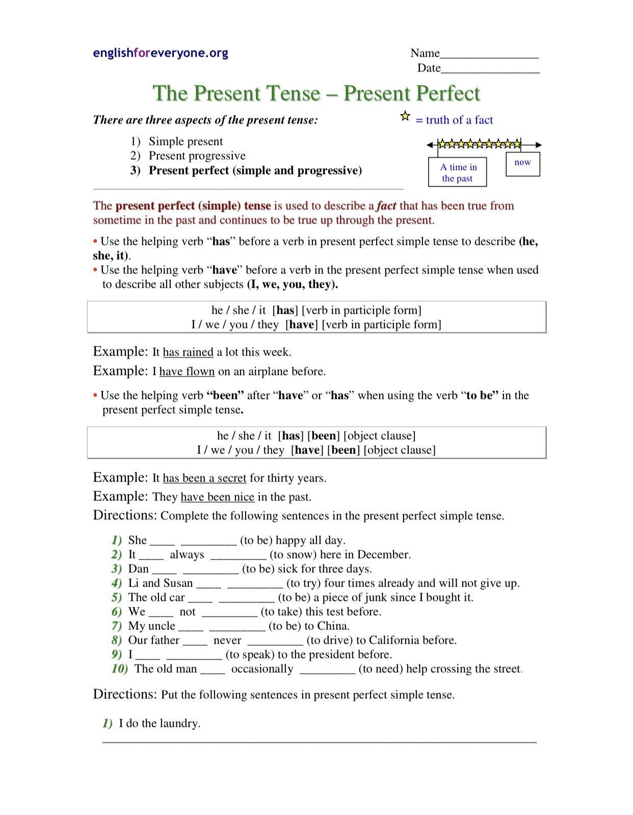
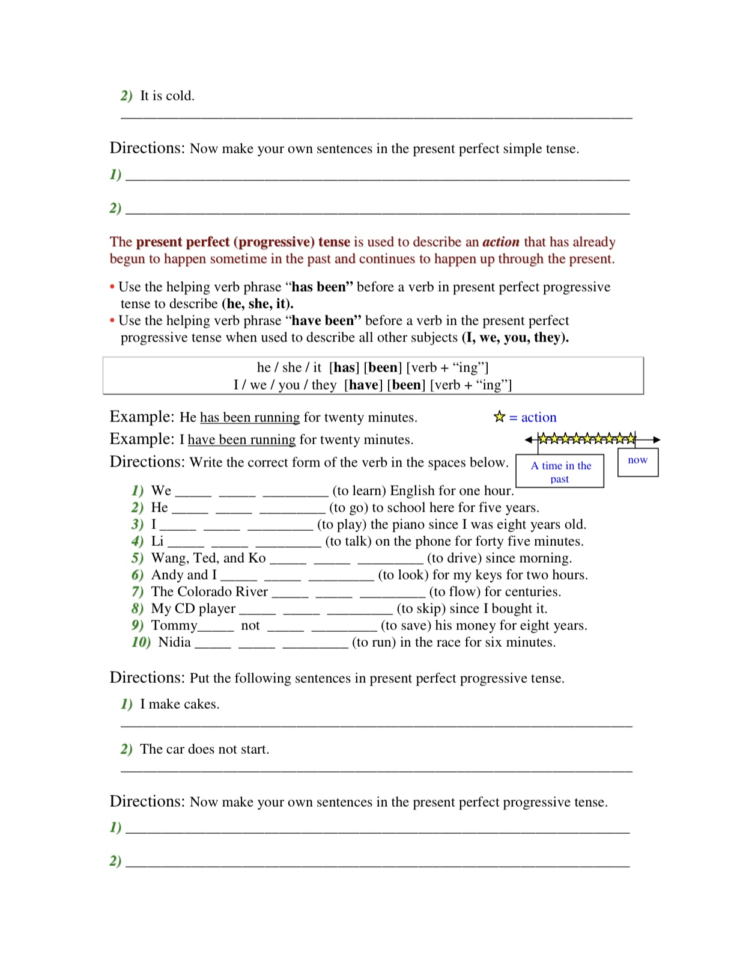
Thursday
Objective(s): I will be able to write an argumentative essay.

Today, your task is to write an argumentative essay. An argumentative essay requires you to make a thesis statement in the beginning and use detailed evidence to support your argument throughout your essay. Skills that you develop with argumentative essays include: anticipating objections, critical thinking, writing skills, logic and rhetoric, and research skills.

Argumentative essay outline
The process of writing an argumentative essay can be very simple when you follow a well-structured outline. Below, you can see how your paper should look like:
- Introduction – first contact between a reader and your essay. This is your chance to make a great first impression, keep reader eager to see how you developed the argument. An introductory paragraph consists of:
  - Hook – first sentence or two; catches reader’s attention. It can be a quote, question, anecdote, statistics, etc.
  - Background – useful background information about the subject
  - Thesis statement – announces the argument you’re going to make or side of the issue that you’ll defend. Example: I believe school should not require students to wear uniforms.
- Developing the argument – are you pro or against some idea, event, policy etc? Explain why you’re right, create an engaging argument that stirs debate in a reader’s mind too. The number of paragraphs isn’t specified, it depends on claims you make:
  - Claim 1 – evidence – each paragraph should start with a claim that contributes to your argument and evidence to support it
  - Claim 2 – evidence
  - Claim 3 – evidence
- Address the opposing views – you want a reader to know you’re right and the best way to do so is to debunk some opposing claims in the process. After developing your argument, dedicate a body paragraph or two to opponents’ viewpoints:
  - Opposing view 1 – refutation – mentions common claims that contradict yours and provides evidence to show why they’re wrong
  - Opposing view 2 – refutation
- Conclusion – restates the main premise or argument and summarizes key claims.

Argumentative essay prompt:
It is now easier than ever to access the internet, whether you are using a computer, phone or tablet. There is no doubt that many young people are spending more and more time online, with both positive and negative consequences. So, is the internet good or bad for children? Use the above outline to write an argumentative essay, your essay should have at least four paragraphs. Don’t forget to make a clear thesis statement in your introduction.

Friday
Objective(s): I will be able to understand and make use of the past, present, and future perfect tenses.

Today we are going to learn about the future perfect tense. Future perfect tense represents an action which will have been occurred at some time in the future. If two actions take place in the future, the first one is future perfect tense and the second one is simple present tense. Watch the video https://youtu.be/n2nin-1VdIo to learn a bit more about future perfect tense.

The future perfect is composed of two elements
the simple future of the verb "to have" (will have) + the past participle of the main verb
Subject + will have + past participle of the main verb
He will have finished.
I will have finished.

The future perfect tense refers to a completed action in the future. When we use this tense we are projecting ourselves forward into the future and looking back at an action that will be completed some time later than now. It is most often used with a time expression.

How to make the Future Perfect Negative
Making a negative future perfect construction is easy. Just insert not between will and have.
- We will not have eaten breakfast before we get to the airport tomorrow morning.
- They will not have finished decorating the float before the parade.
You can also use the contraction won’t in the place of will not.
- They won’t have finished decorating the float before the parade.

How to Ask a Question
The formula for asking a question in the future perfect tense is will + [subject] + have + [past participle]:
- Will you have eaten lunch already when we arrive?
- Will they have finished decorating the float before the parade?

Examples:
I will have been here for six months on June 23rd.
By the time you read this I will have left.
You will have finished your report by this time next week.
Won't they have arrived by 5:00?
Will you have eaten when I pick you up?
Practice:
Rewrite the sentences in the future perfect tense.
- Haley will visit her grandpa.
____________________________
2. John will go to school on Friday. ____________________________________________
3. My brother will eat tacos for dinner. ____________________________________________
4. Our team will win the game today. ____________________________________________
5. My parents will want to go to the store on Saturday. ____________________________________________
6. My computer will work well for Spanish class. ____________________________________________
7. In our classroom, we will sit in desks. ____________________________________________
8. My friends will bring me presents for the party. ____________________________________________

Now try on your own:
1. Write a sentence using the future tense. ____________________________________________
2. Write the same sentence using the future perfect tense. ____________________________________________

Fill in the blanks to complete the sentences in the future perfect tense.
1. Harry will have studied (study) for 12 years when he graduates.
2. Our team ________________ (finish) our season by September.
3. Her sister ________________ (do) research before writing her essay. 4. The dog ______________ (sleep) for 6 hours by the time I got home.
5. By Sunday, my parents ________________ (paint) the whole house.
6. I ________________ (clean) everything before my brother wakes up.
7. We ________________ (learn) a lot by the end of the year.
8. The horse ________________ (leave) the barn by now if the gate was open.

Now try on your own:
1. Form a sentence using the future tense. _______________________________________________________
2. Form a sentence using the future perfect tense.
_______________________________________________________

Write if the verb tense is past perfect, present perfect or future perfect.
1. The painter has painted three major works of art. present perfect
2. My mom has cooked dinner every night this week. _______________
3. The mouse had eaten all the cheese in the trap. _______________
4. My principal will have given two speeches before the end of the school day. _______________
5. My sister had visited my grandparents on her way to her friend’s house. _______________
6. The dog and the cat have sprinted around the yard all day long. _______________
7. We will have taken the test before we go outside for recess. _______________
8. The plumber will have fixed the sink before I arrive home today. _______________
Complete the sentence with the correct perfect tense of the verb.
1. My parents have seen (see) this movie two times at the cinema.
2. My brother ______________ (eat) the cake before I had a chance to get a bite.
3. Before we move to the new house, we ______________ (pack) all of our clothes.
4. The lawyer ______________ (say) that we can tour her office anytime we want.

